ASSIGNMENT-6.5

NAME: R.Karthik
H.T.NO: 2303A52202
BATCH: 35
Experiment 6:
Task Description #1 (AI-Based Code Completion for Conditional
Eligibility Check)
Task: Use an AI tool to generate eligibility logic.
Prompt:
“Generate Python code to check voting eligibility based on age and
citizenship.”
Expected Output:
• AI-generated conditional logic.
• Correct eligibility decisions.
• Explanation of conditions.
CODE:
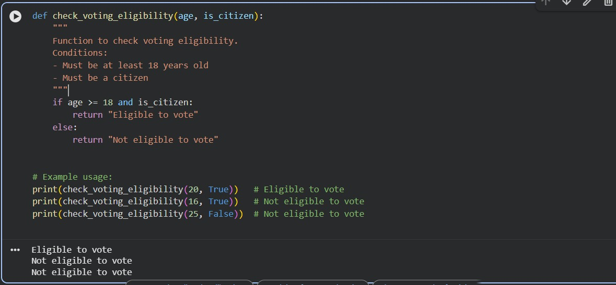
EXPLANATION:
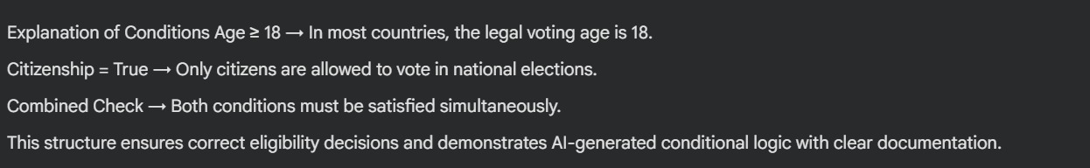
Task Description #2(AI-Based Code Completion for Loop-Based
String Processing)
Task: Use an AI tool to process strings using loops.
Prompt:
“Generate Python code to count vowels and consonants in a string
using a loop.”
Expected Output:
• AI-generated string processing logic.
• Correct counts.
• Output verification.
CODE:
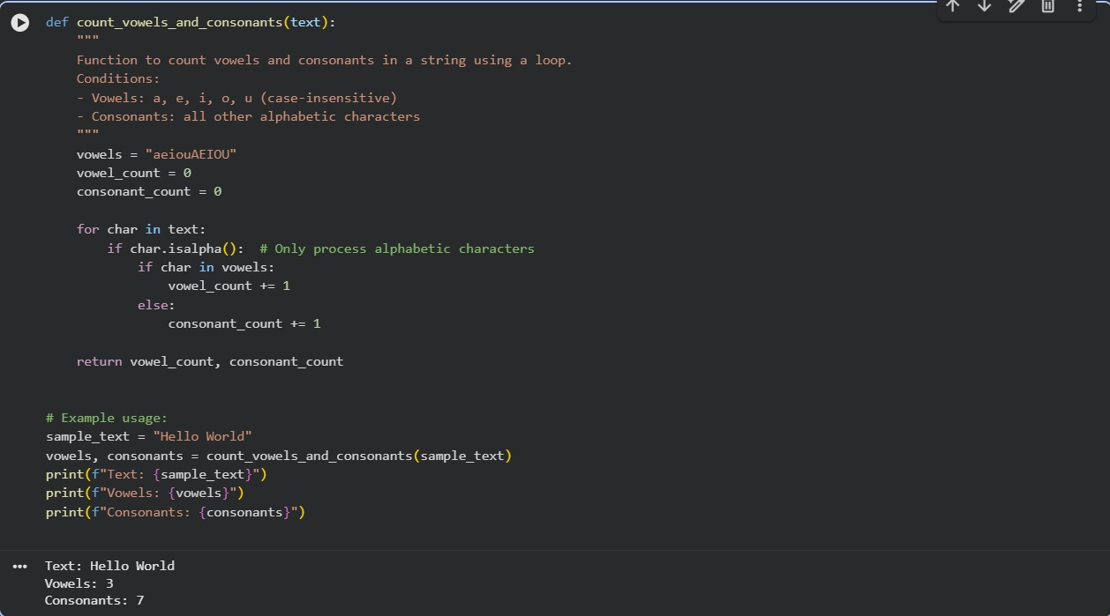
EXPLANATION:
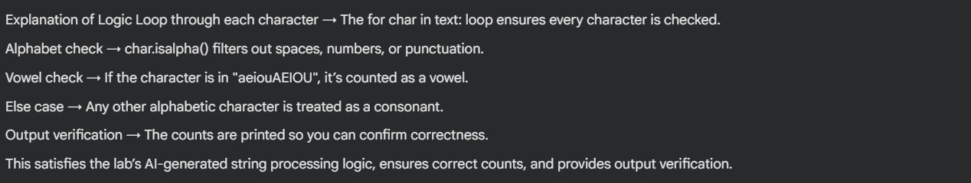
Task Description #3 (AI-Assisted Code Completion Reflection
Task)
Task: Use an AI tool to generate a complete program using classes,
loops, and conditionals.
Prompt:
“Generate a Python program for a library management system
using classes, loops, and conditional statements.”
Expected Output:
• Complete AI-generated program.
• Review of AI suggestions quality.
• Short reflection on AI-assisted coding experience.
CODE:
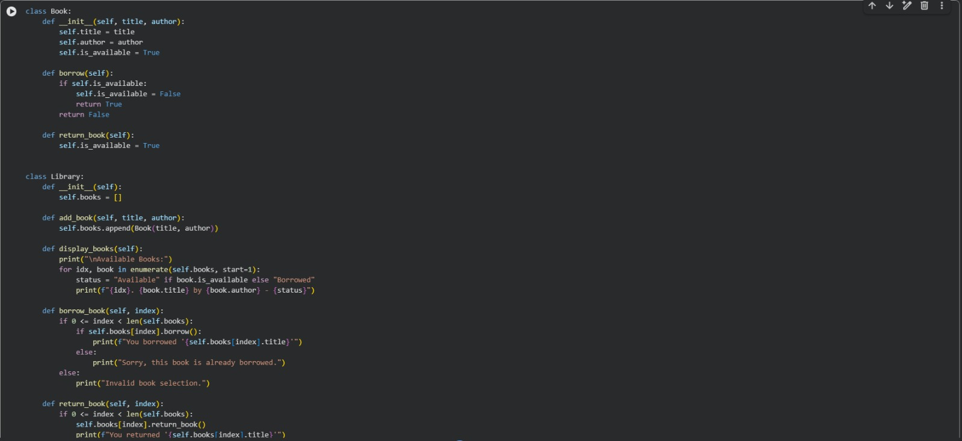
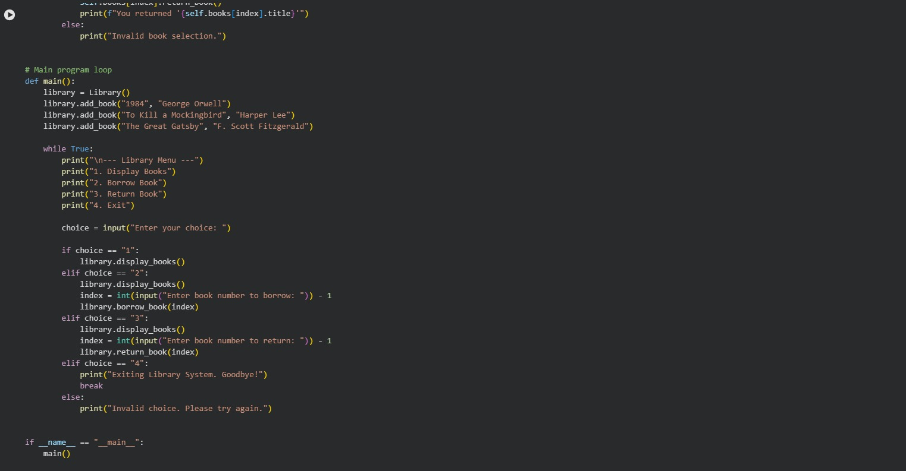
OUTPUT:
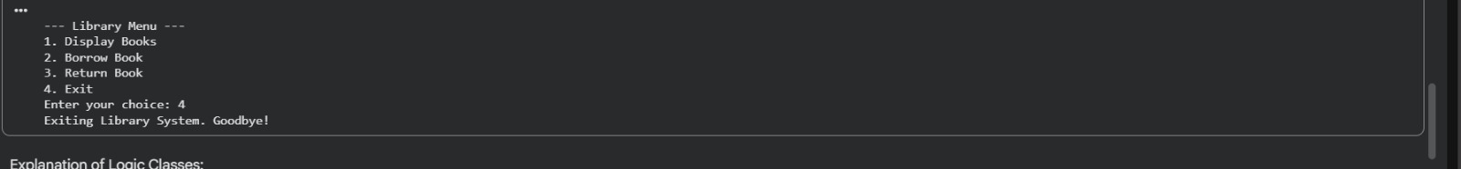
EXPLANATION:
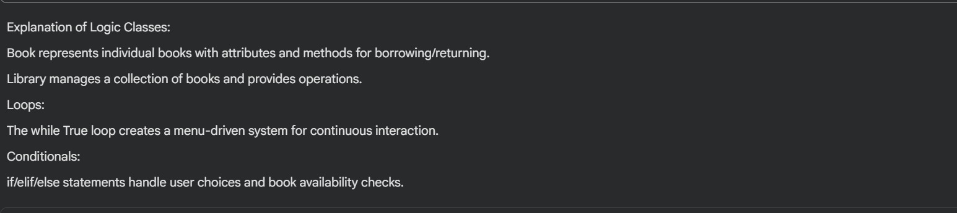
Task Description #4 (AI-Assisted Code Completion for Class-
Based Attendance System)
Task: Use an AI tool to generate an attendance management class.
Prompt: “Generate a Python class to mark and display student
attendance using loops.”
Expected Output:
• AI-generated attendance logic.
• Correct display of attendance.
• Test cases.
CODE:
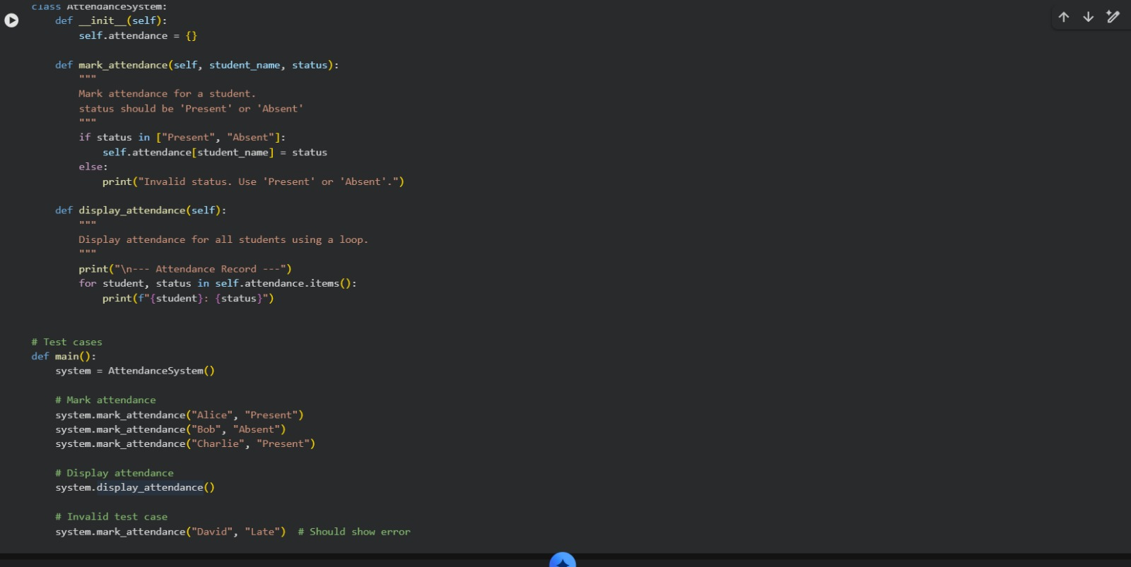
OUTPUT:
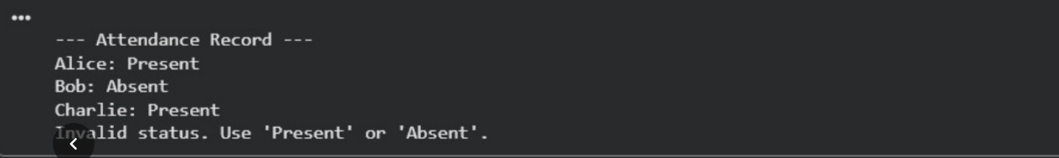
EXPLANATION:
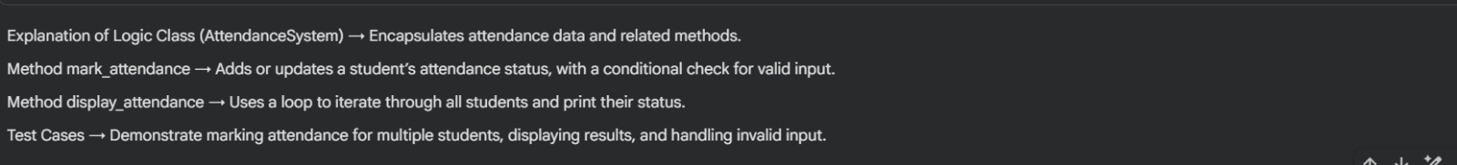
Task Description #5 (AI-Based Code Completion for Conditional
Menu Navigation)
Task: Use an AI tool to complete a navigation menu.
Prompt: “Generate a Python program using loops and conditionals
to simulate an ATM menu.”
Expected Output:
• AI-generated menu logic.
• Correct option handling.
• Output verification.
CODE:
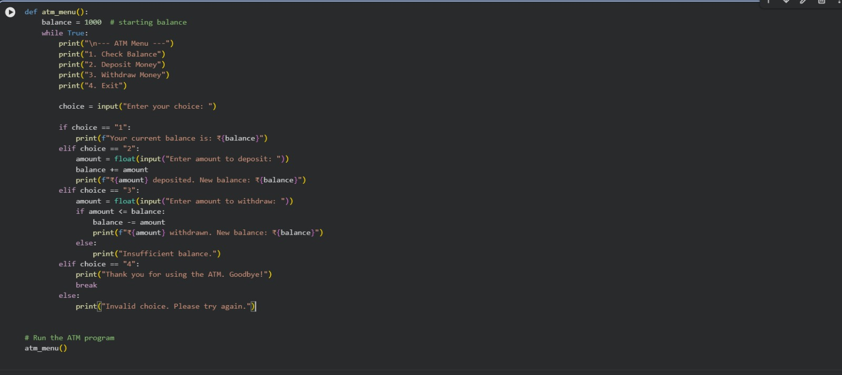
OUTPUT:
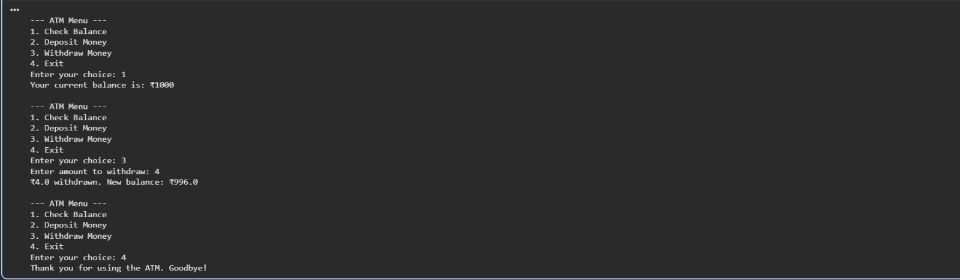
EXPLANATION:
